Pledge against Child Marriage in Nayagarh, Orissa
- Villagers of NOTARAPALLI, Odagaon Block, Nayagarh takes a mass resolution not to permit child marriage in their village.
- Vow “Not to give and take dowry”.
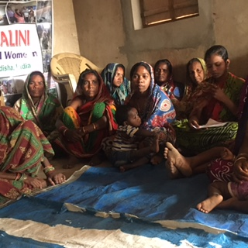
- Vow to provide “Equal opportunity of Education to both boys and girls”.
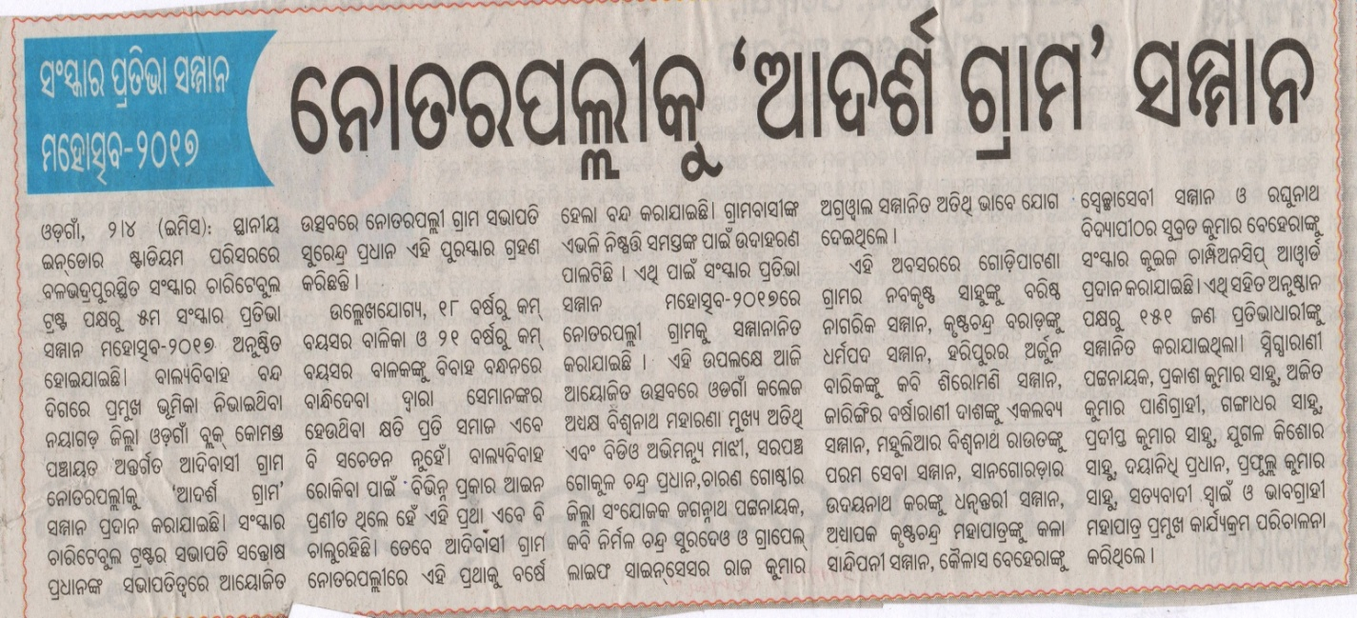
News Clips

